Project 1

Title
Battleship!

CIS 17A-47465
Tyler Purba
November 4th 2025

C++ Implementation of the Battleship Game
- Introduction
Battleship is a classic strategy board game that has been around for decades. Most people know it as a logic-based guessing game, although, if I’m being honest, I didn’t think there was much “strategy” involved until I played it in high school. Then I realized something very important:
it’s really just a guessing game, and everyone is pretending otherwise :)
Still Battleship feels strategic, and it balances logic, intuition, and prediction in a way that makes it a perfect candidate for a programming project. I chose it because it naturally requires many of the concepts we’ve learned in CIS-17A: dynamic arrays, structures, pointers, functions, and even binary file handling. This project wasn’t just another coding exercise like the usual, it allowed me to actually build a fully working game from scratch.
The rules are simple and well-documented, the game has existed far longer than I have, and almost everyone recognizes the idea: place ships, guess coordinates, and try not to get obliterated. Simple in theory and surprisingly very complicated in code.

2. Summary

2.1 Project Size and Line Count
The project ended with 588 lines of code, which far exceeds the minimum requirement of 250 and reflects the number of systems that had to work together including board creation, ship placement, input validation, turn logic, hit detection, win conditions, and of course statistics tracking.

2.2 Variables and Constructs Used
I used a wide range of variables and data structures, including:
- Multiple structs
- Dynamic 2D arrays for both the fleet and shot boards
- Dynamic arrays of structures for each player's fleet
- Character arrays and C-strings
- Standard strings
- Pointers and references
- Binary file I/O for stats
- Numerous helper functions passing structures in and out

2.3 Time Spent & Challenges
This project took longer than expected. Much longer. Originally, I planned to include two modes, Player vs Player and Player vs CPU. After hours of trying to design the AI, I realized two things:
- Making AI that is not trivially stupid is hard.
- Making AI that is not rage-quit impossible is even harder.
So the CPU mode was scrapped, and I left the CPU struct in the code as a potential future enhancement for the game. Player vs Player alone already satisfied the project requirements and was more than enough work on its own.
The biggest challenges were:
- Managing four separate 2D dynamic boards
- Preventing out-of-bounds ship placement
- Validating user input like “A10” without letting the program explode
- Keeping everything organized without using classes
Despite the difficulty, the project fully meets and exceeds the requirements for Project 1. It demonstrates dynamic memory management, structures, arrays of structures, pointers, binary files, and a complete, playable game loop. It also leaves the door open for future improvements once we start using classes and object-oriented programming.

3. Description

3.1 Overview of Program Structure
To build the Battleship game, I divided the program into several logical systems that work together:

1. Board System (Dynamic 2D Arrays)
Each player has two dynamic boards:
- A fleet board showing where their ships are placed
- A shot board showing their guesses against the opponent
These boards are created using dynamic 2D arrays (char**) allocated with new and cleaned up using delete[]. The boards store:
- '.' for empty
- 'S' for a ship
- 'X' for a hit
- 'O' for a miss

2. Struct-Based Game Data
The entire game is built around structures (Ship, Plyr, Stat).
No classes, following the project rules.
Each structure contains:
- Ship: name, size, hits, direction, row/col
- Player: name, 2 boards, array of ships
- Stat: name, games played, games won
All these are passed into functions as required to show structure I/O.

3. Ship Placement System
Players manually enter ship positions during the setup phase.
The program:
- Converts coordinates (like "A10") into row/column values
- Validates ship placement
- Writes ship locations into the fleet board

4. Turn System / Shooting System
Each turn:
- The attacker views their fleet and shot boards
- The player inputs a target location (like "G7")
- The game checks whether the target is a hit or miss
- Boards are updated accordingly
- The game checks if a full ship is sunk
- The other player takes their turn
This continues until one player has all ships sunk.

5. Stats System (Binary File I/O)
After a game ends:
- The winner and loser stats are updated
- Updated stats are written into bstats.dat
- Stats persist between runs
- Users can view all past stats from the main menu
This demonstrates reading/writing raw structures from binary files.
3.2 Input/Output
Starting Menu:
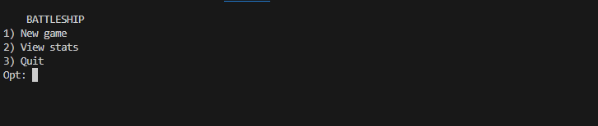
Player name enter
Input: 1
Player1
Player2
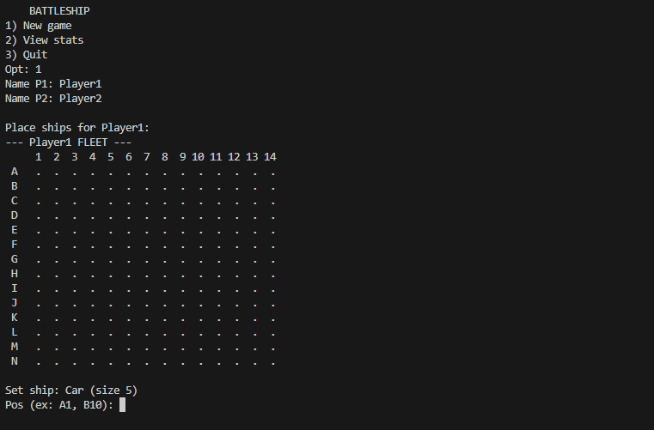
Setting up ships
Input: A1
V
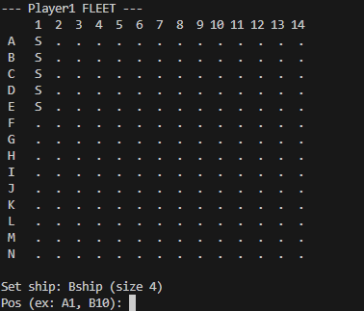
A3
H
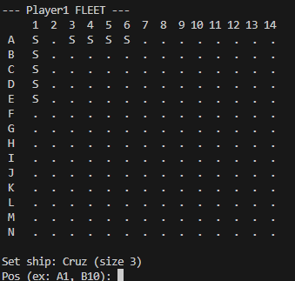
A1
V (again)
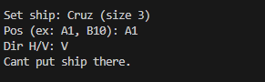
Choosing who goes first
Input: 50
72
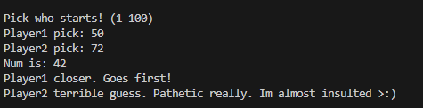
Taking a shot
Input: A1
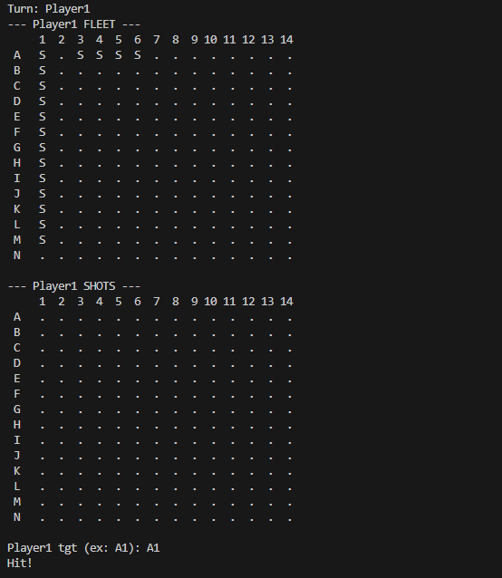
Missing a shot
Input: N14
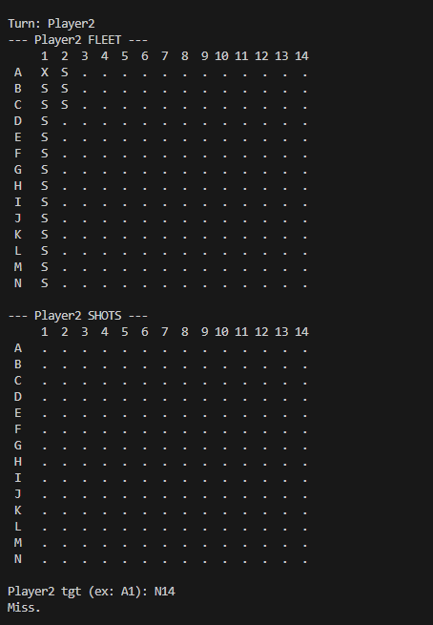
Endgame:
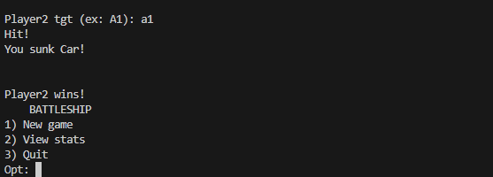
Viewing Stats
Input: 2
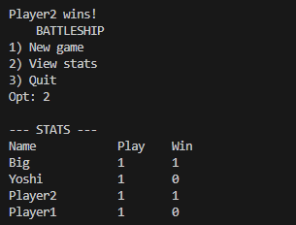

4.1 Flowcharts / Pseudocode
4.2 Flowchart
Flowchart 1 -Main Program and Menu
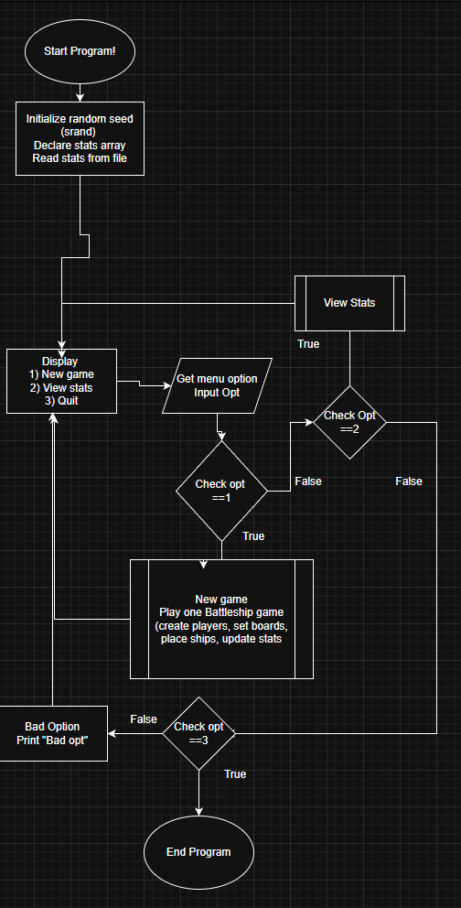
Flowchart 2 – Ship Placement
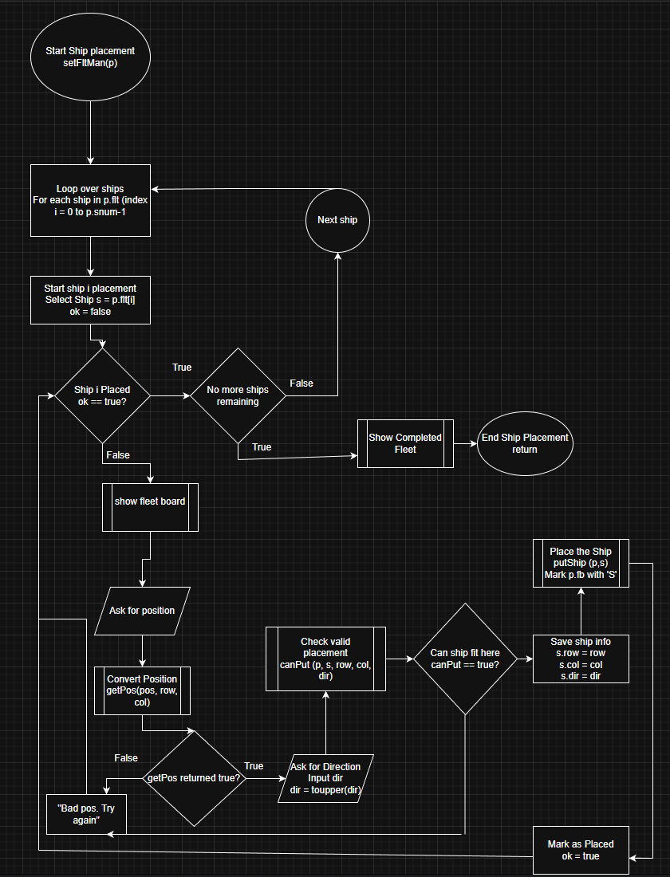
Flowchart 3-Player turn
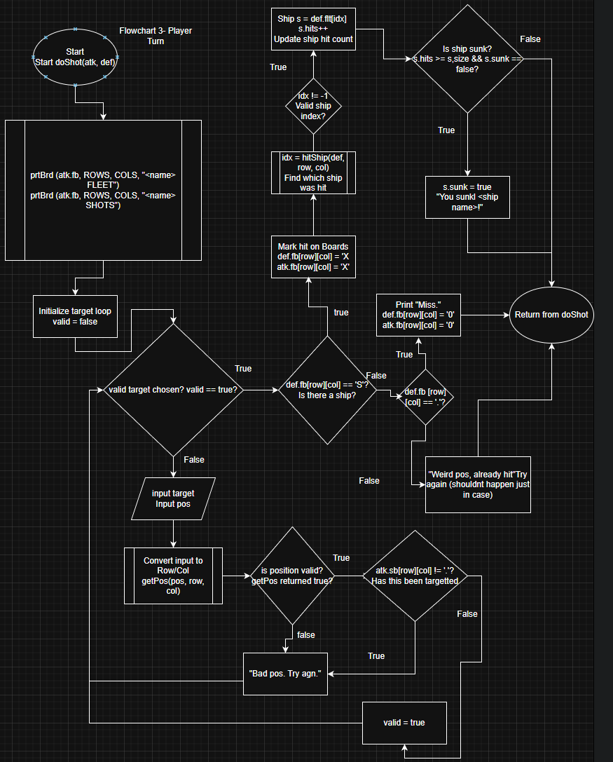
4.3 Pseudocode
Main Program
Start program
Load stats from binary file

Loop menu:
Display options: New Game, View Stats, Quit
If New Game → startMatch()
If View Stats → show stats table
If Quit → exit loop
Save stats on exit
End program

startMatch()
Prompt for player names
Initialize both player structs
Allocate boards and fleets

Each player places ships manually

Run choose-first-number game
Set currentPlayer = winner

While game not over:
currentPlayer fires shot
Mark hit or miss
If a ship is sunk → announce
If all ships sunk → winner declared
Switch turns
Update stats and write to file
Deallocate memory

Ship Placement:
For each ship:
Show board
Ask for position and direction
Validate position
If valid → place ship on board
Else → retry

Firing a Shot:
Ask player for coordinate
Validate input and ensure not already used

If coordinate hits a ship:
Mark hit on both boards
Increment ship's hit counter
If hits == size → ship is sunk

Else:
Mark miss

Stats System:
Read stats from binary file at start
On game end:
Find player entry or create one
Increment play counter
If player won → increment win
Write updated stats back to binary file

5. Variables
5.1 Major Structs
These are the main data structures used by the program to represent ships, players, and statistics.

Struct Ship
Type | Name | Description | Location
char | name[8] | Short ship name (e.g. "Car", "Bship") used in messages | Global struct Ship
int | size | Length of the ship in board cells | Global struct Ship
int | hits | Number of times this ship has been hit | Global struct Ship
bool | sunk | true if the ship has been sunk | Global struct Ship
int | row | Starting row index (0–ROWS-1) of the ship | Global struct Ship
int | col | Starting column index (0–COLS-1) of the ship | Global struct Ship
char | dir | Direction: 'H' for horizontal, 'V' for vertical | Global struct Ship

Struct Plyr (Player)
Type | Name | Description | Location
char | name[16] | Player name, stored as C-string | Global struct Plyr
char** | fb | Fleet board (dynamic 2D array of characters) | Global struct Plyr
char** | sb | Shot board (dynamic 2D array of characters) | Global struct Plyr
Ship* | flt | Dynamic array of ships belonging to this player | Global struct Plyr
int | snum | Number of ships in flt (always SNUM in this game) | Global struct Plyr

Struct Stat (Statistics for persistent scoring)
Type | Name | Description | Location
char | name[16] | Player name associated with these stats | Global struct Stat
int | play | Number of games played by this player | Global struct Stat
int | win | Number of games won by this player | Global struct Stat

Struct Cpu (reserved for future CPU AI)
This struct is defined but not used in the current project. It was planned for a CPU opponent mode but left for a future version.
Type | Name | Description | Location
bool | tgt | true if CPU is in “target mode” | Global struct Cpu
int | hr | Last hit row | Global
int | hc | Last hit column | Global
int | qnum | How many items are stored in the target queue | Global
int | qr[20] | Queue of candidate target rows | Global
int | qc[20] | Queue of candidate target columns | Global

5.2 Global Constants
These constants control board size, fleet size, and stats file settings.
Type | Name | Value | Description | Location
const int | ROWS | 14 | Number of rows on the board (A–N) | Global
const int | COLS | 14 | Number of columns on the board (1–14) | Global
const int | SNUM | 5 | Number of ships per player | Global
const int | MS | 20 | Maximum number of statistics records saved | Global
const char | SFIL[] | "bstats.dat" | File name used to store persistent stats (binary) | Global
These values are used throughout the program instead of “magic numbers,” so if board size or stats capacity changes, it can be adjusted in one place.

5.3 Main Function Variables
These are the most important variables defined in main that control the game loop and menu.
Type | Name | Description | Location
Stat | st[MS] | Array storing stats records loaded from file | Inside main
int | sn | Current number of valid records in st | Inside main
int | opt | Menu option chosen by the user | Inside main
Plyr | p1 | Player structure for player 1 | runGame section
Plyr | p2 | Player structure for player 2 | runGame section
char | nm1[16] | Raw C-string for player 1’s name input | runGame section
char | nm2[16] | Raw C-string for player 2’s name input | runGame section
Plyr* | cur | Pointer to current player taking a turn | runGame / turn loop
Plyr* | oth | Pointer to the other player (defender) | runGame / turn loop
Plyr* | tmp | Temporary pointer used for swapping cur/oth | runGame turn loop

5.4 Board and Input Variables (Key Local Variables)
Board / Position Variables
Type | Name | Description | Location
int | row | Row index (0–ROWS-1) for a board cell | getPos, setFltMan, doShot
int | col | Column index (0–COLS-1) for a board cell | getPos, setFltMan, doShot
int | idx | Index for ship found at a hit position | doShot (result from hitShip)
int | d1 | Distance between player 1 guess and target number | pickFr
int | d2 | Distance between player 2 guess and target number | pickFr
int | tgt | Random target number from 1–100 used to choose who starts | pickFr
String / Text Variables
Type | Name | Description | Location
string | pos | Raw user input for coordinates like "A10" | setFltMan, doShot
string | ttl | Title string used to label boards when printing | setFltMan, prtBrd
string | ttl1 | Title for current player’s fleet board | doShot
string | ttl2 | Title for current player’s shot board | doShot
string | cStr | Numeric substring of coordinate string (e.g. "10") | getPos
These help convert simple text like "B7" into row/column indices and give more readable titles when drawing the boards.

5.5 Dynamic Memory Variables
The following pointer variables are used for dynamic memory allocation and deallocation, satisfying the requirement for pointers and arrays:
Type | Name | Description | Location
char** | fb | Points to a dynamically allocated 2D array for fleet board | Member of Plyr
char** | sb | Points to a dynamically allocated 2D array for shot board | Member of Plyr
Ship* | flt | Points to a dynamically allocated array of ships | Member of Plyr
These pointers are allocated in setPly using mkBrd and new Ship[...], and they are freed in delPly using delBrd and delete[]. This demonstrates dynamic 2D arrays, arrays of structures, and proper pointer usage.

6. Concepts Used

Chapter 9 – Pointers & Dynamic Memory

Dynamic Memory Allocation (new/delete)
Used to build every game board:
p.fb = mkBrd(ROWS, COLS);
p.sb = mkBrd(ROWS, COLS);
p.flt = new Ship[p.snum];
Deleted at the end:
delBrd(p.fb, ROWS);
delete [] p.flt;

Pointers to Arrays
The 2D boards use char** pointers and pointer arithmetic is handled internally:
char **mkBrd(int row, int col);

Pointers Passed Into Functions
Every major game function accepts pointers or structures containing pointers:
- doShot(Plyr &atk, Plyr &def)
- setFltMan(Plyr &p)
- pickFr(Plyr &p1, Plyr &p2, Plyr *&cur, Plyr *&oth)

Pointers to Structures
Accessing structure members through pointers:
cur->name
oth->flt[i]

Returning Pointers
mkBrd returns a dynamically allocated pointer:
char **mkBrd(int row, int col);

Relationship Between Arrays and Pointers
brd[r][c] = 'S';

Chapter 10 – Characters, C-Strings, and the string Class

Character Arrays (C-Strings)
Player names and ship names use fixed-size char[] arrays:
char name[16];
char shipName[8];

C-String Functions (strcpy, strncpy, strcmp)
Used throughout:
strcpy(flt[0].name, "Car");
strncpy(p.name, nm, 15);
strcmp(st[i].name, nm) == 0

Character Case Conversion
Used when processing user input:
dir = toupper(dir);
char rCh = toupper(in[0]);

String Objects
Used for UI text and board titles:
string ttl = string(p.name) + " FLEET";

Mixing C-Strings and string

Chapter 11 – Structured Data (struct)

Multiple Structures Created
- Ship
- Plyr
- Stat
- Cpu (reserved for future CPU mode)

Arrays of Structures
Each player has:
Ship *flt // dynamic array of Ship

Structures as Function Arguments
void doShot(Plyr &atk, Plyr &def);
bool canPut(Plyr &p, Ship &s, int row, int col, char dir);

Structures Containing Pointers
Plyr contains pointers to:
- dynamic boards
- dynamic array of ships

Pointers to Structures
Used everywhere:
Plyr *cur = &p1;
cur->flt[i]

Chapter 12 – Files, Formatting, and Binary I/O

Binary File Reading/Writing
Stat structures are stored in bstats.dat using binary mode:
fin.read(reinterpret_cast<char*>(&st[n]), sizeof(Stat));
fout.write(reinterpret_cast<char*>(&st[i]), sizeof(Stat));

File Opening and Error Handling
ifstream fin(SFIL, ios::binary);
ofstream fout(SFIL, ios::binary);

Creating Records Using Structures
Each Stat entry is a serialized structure in the file.

Passing File Streams to Functions
Indirectly shown by placing file logic inside helper functions (rdStat, wrStat).

- References
Textbook
cplusplus.com (references to clarify function behavior)
battleshiponline.org
Class Lectures

Program: /*
* File: main.cpp
* Author: Tyler Purba
*
* Proj: Battleship Game
* Desc: Board + basic structs (step 1)
*/

#include <iostream>
#include <iomanip>
#include <cstdlib>
#include <ctime>
#include <fstream>
#include <string>
#include <cctype> // toupper
#include <cstring> // strcpy

using namespace std;

// Board size
const int ROWS = 14; // A-N
const int COLS = 14; // 1-14
const int SNUM = 5; // number of ships

// -----------------
// Structs
// -----------------

struct Ship {
char name[8]; // ship name
int size; // length
int hits; // hits so far
bool sunk; // true if dead
int row; // start row
int col; // start col
char dir; // 'H' or 'V'
};

struct Plyr {
char name[16]; // player name
char **fb; // fleet board
char **sb; // shot board
Ship *flt; // ships
int snum; // ship count
};

struct Stat {
char name[16]; // player name
int play; // games played
int win; // games won
};

struct Cpu {
bool tgt; // in target mode
int hr; // last hit row
int hc; // last hit col
int qnum; // queue size
int qr[20]; // row queue
int qc[20]; // col queue
};

int dice();
int hitShip(Plyr &def, int row, int col);
bool allSunk(Plyr &p);
void doShot(Plyr &atk, Plyr &def);

const int MS = 20; // max stats rec
const char SFIL[] = "bstats.dat"; // stats file name

// stats funcs
int rdStat(Stat st[], int max);
void wrStat(Stat st[], int sn);
int findSt(Stat st[], int sn, const char nm[]);
void updSt(Stat st[], int &sn, const char nm[], bool win);
void shwSt(Stat st[], int sn);

// who starts
void pickFr(Plyr &p1, Plyr &p2, Plyr *&cur, Plyr *&oth);

// -----------------
// Board functions
// -----------------
char **mkBrd(int row, int col);
void delBrd(char **brd, int row);
void clrBrd(char **brd, int row, int col, char ch);
void prtBrd(char **brd, int row, int col, const string &ttl);

int dice() {
return rand() % 6 + 1; // 1-6
}

int hitShip(Plyr &def, int row, int col) {
for (int i = 0; i < def.snum; i++) {
Ship &s = def.flt[i];
int r = s.row;
int c = s.col;

if (s.dir == 'H') {
for (int k = 0; k < s.size; k++) {
if (r == row && (c + k) == col) {
return i;
}
}
} else { // 'V'
for (int k = 0; k < s.size; k++) {
if ((r + k) == row && c == col) {
return i;
}
}
}
}
return -1; // not on any ship (should only happen if cell not 'S')
}

bool allSunk(Plyr &p) {
for (int i = 0; i < p.snum; i++) {
if (!p.flt[i].sunk) return false;
}
return true;
}

void mkFlt(Ship *flt, int snum) {
strcpy(flt[0].name, "Car");
flt[0].size = 5;

strcpy(flt[1].name, "Bship");
flt[1].size = 4;

strcpy(flt[2].name, "Cruz");
flt[2].size = 3;

strcpy(flt[3].name, "Sub");
flt[3].size = 3;

strcpy(flt[4].name, "Dest");
flt[4].size = 2;

for (int i = 0; i < snum; i++) {
flt[i].hits = 0;
flt[i].sunk = false;
flt[i].row = 0;
flt[i].col = 0;
flt[i].dir = 'H';
}
}

void setPly(Plyr &p, const char nm[]) {
strncpy(p.name, nm, 15);
p.name[15] = '\0';

p.snum = SNUM;

p.fb = mkBrd(ROWS, COLS);
p.sb = mkBrd(ROWS, COLS);

clrBrd(p.fb, ROWS, COLS, '.');
clrBrd(p.sb, ROWS, COLS, '.');

p.flt = new Ship[p.snum];
mkFlt(p.flt, p.snum);
}

void delPly(Plyr &p) {
if (p.fb != nullptr) {
delBrd(p.fb, ROWS);
p.fb = nullptr;
}
if (p.sb != nullptr) {
delBrd(p.sb, ROWS);
p.sb = nullptr;
}
if (p.flt != nullptr) {
delete [] p.flt;
p.flt = nullptr;
}
}

bool canPut(Plyr &p, Ship &s, int row, int col, char dir) {
if (dir == 'H') {
if (col + s.size > COLS) return false;
for (int c = col; c < col + s.size; c++) {
if (p.fb[row][c] != '.') return false;
}
} else if (dir == 'V') {
if (row + s.size > ROWS) return false;
for (int r = row; r < row + s.size; r++) {
if (p.fb[r][col] != '.') return false;
}
} else {
return false;
}
return true;
}

void putShip(Plyr &p, Ship &s) {
int row = s.row;
int col = s.col;

if (s.dir == 'H') {
for (int c = col; c < col + s.size; c++) {
p.fb[row][c] = 'S';
}
} else {
for (int r = row; r < row + s.size; r++) {
p.fb[r][col] = 'S';
}
}
}

// player + fleet setup
void setPly(Plyr &p, const char nm[]);
void delPly(Plyr &p);
void mkFlt(Ship *flt, int snum);

// ship place helpers
bool getPos(const string &in, int &row, int &col);
bool canPut(Plyr &p, Ship &s, int row, int col, char dir);
void putShip(Plyr &p, Ship &s);

// manual fleet (strategy panel)
void setFltMan(Plyr &p);

void setFltMan(Plyr &p) {
for (int i = 0; i < p.snum; i++) {
Ship &s = p.flt[i];

bool ok = false;
while (!ok) {
string ttl = string(p.name) + " FLEET";
prtBrd(p.fb, ROWS, COLS, ttl);

cout << "Set ship: " << s.name
<< " (size " << s.size << ")" << endl;
cout << "Pos (ex: A1, B10): ";
string pos;
cin >> pos;

int row, col;
if (!getPos(pos, row, col)) {
cout << "Bad pos. Try agn." << endl << endl;
continue;
}

cout << "Dir H/V: ";
char dir;
cin >> dir;
dir = toupper(dir);

if (!canPut(p, s, row, col, dir)) {
cout << "Cant put ship there." << endl << endl;
continue;
}

s.row = row;
s.col = col;
s.dir = dir;
putShip(p, s);
ok = true;
}
}

string ttl = string(p.name) + " FLEET DONE";
prtBrd(p.fb, ROWS, COLS, ttl);
}

bool getPos(const string &in, int &row, int &col) {
if (in.size() < 2) return false;

char rCh = toupper(in[0]);
if (rCh < 'A' || rCh > 'A' + ROWS - 1) return false;

string cStr = in.substr(1);
int cNum = 0;

for (int i = 0; i < static_cast<int>(cStr.size()); i++) {
if (!isdigit(cStr[i])) return false;
cNum = cNum * 10 + (cStr[i] - '0');
}

if (cNum < 1 || cNum > COLS) return false;

row = rCh - 'A';
col = cNum - 1;

return true;
}

int rdStat(Stat st[], int max) {
ifstream fin(SFIL, ios::binary);
if (!fin) return 0;

int n = 0;
while (n < max && fin.read(reinterpret_cast<char*>(&st[n]), sizeof(Stat))) {
n++;
}
fin.close();
return n;
}

void wrStat(Stat st[], int sn) {
ofstream fout(SFIL, ios::binary);
if (!fout) return;
for (int i = 0; i < sn; i++) {
fout.write(reinterpret_cast<char*>(&st[i]), sizeof(Stat)); // binary file//
}
fout.close();
}

int findSt(Stat st[], int sn, const char nm[]) {
for (int i = 0; i < sn; i++) {
if (strcmp(st[i].name, nm) == 0) {
return i;
}
}
return -1;
}

void updSt(Stat st[], int &sn, const char nm[], bool win) {
int idx = findSt(st, sn, nm);

if (idx == -1) {
if (sn >= MS) return;
idx = sn;
sn++;

strncpy(st[idx].name, nm, 15);
st[idx].name[15] = '\0';
st[idx].play = 0;
st[idx].win = 0;
}

st[idx].play++;
if (win) st[idx].win++;
}

void shwSt(Stat st[], int sn) {
cout << endl << "--- STATS ---" << endl;
if (sn == 0) {
cout << "No stat yet." << endl << endl;
return;
}

cout << left << setw(16) << "Name"
<< setw(8) << "Play"
<< setw(8) << "Win" << endl;

for (int i = 0; i < sn; i++) {
cout << left << setw(16) << st[i].name
<< setw(8) << st[i].play
<< setw(8) << st[i].win << endl;
}
cout << endl;
}

void pickFr(Plyr &p1, Plyr &p2, Plyr *&cur, Plyr *&oth) {
const int MINN = 1;
const int MAXN = 100;

while (true) {
int g1, g2;

cout << endl << "Pick who starts! (" << MINN << "-" << MAXN << ")" << endl;

cout << p1.name << " pick: ";
cin >> g1;
while (g1 < MINN || g1 > MAXN) {
cout << "Pick " << MINN << "-" << MAXN << ": ";
cin >> g1;
}

cout << p2.name << " pick: ";
cin >> g2;
while (g2 < MINN || g2 > MAXN) {
cout << "Pick " << MINN << "-" << MAXN << ": ";
cin >> g2;
}

int tgt = rand() % (MAXN - MINN + 1) + MINN;
cout << "Num is: " << tgt << endl;

int d1 = g1 - tgt;
if (d1 < 0) d1 = -d1;
int d2 = g2 - tgt;
if (d2 < 0) d2 = -d2;

if (d1 < d2) {
cout << p1.name << " closer. Goes first!" << endl;
cout << p2.name << " terrible guess. Pathetic really. Im almost insulted >:)" << endl;
cur = &p1;
oth = &p2;
break;
} else if (d2 < d1) {
cout << p2.name << " closer. Goes first!" << endl;
cout << p1.name << " that was an awful guess. You deserve to lose :)" << endl;
cur = &p2;
oth = &p1;
break;
} else {
cout << "Tie. You both suck. Try again :)" << endl;
}
}
}

int main(int argc, char** argv) {
srand(static_cast<unsigned int>(time(0)));

Stat st[MS];
int sn = rdStat(st, MS);

int opt = 0;
while (true) {
cout << " BATTLESHIP " << endl;
cout << "1) New game" << endl;
cout << "2) View stats" << endl;
cout << "3) Quit" << endl;
cout << "Opt: ";
cin >> opt;

if (opt == 1) {
Plyr p1, p2;
p1.fb = p1.sb = nullptr;
p1.flt = nullptr;
p2.fb = p2.sb = nullptr;
p2.flt = nullptr;

char nm1[16], nm2[16];

cout << "Name P1: ";
cin >> setw(16) >> nm1;

cout << "Name P2: ";
cin >> setw(16) >> nm2;

setPly(p1, nm1);
setPly(p2, nm2);

cout << endl << "Place ships for " << p1.name << ":" << endl;
setFltMan(p1);

cout << endl << "Place ships for " << p2.name << ":" << endl;
setFltMan(p2);

Plyr *cur = &p1;
Plyr *oth = &p2;
pickFr(p1, p2, cur, oth);

while (true) {
cout << endl << "Turn: " << cur->name << endl;
doShot(*cur, *oth);

if (allSunk(*oth)) {
cout << endl << cur->name << " wins!" << endl;

updSt(st, sn, cur->name, true);
updSt(st, sn, oth->name, false);
wrStat(st, sn);

break;
}

Plyr *tmp = cur;
cur = oth;
oth = tmp;
}

delPly(p1);
delPly(p2);
}
else if (opt == 2) {
shwSt(st, sn);
}
else if (opt == 3) {
break;
}
else {
cout << "Bad opt." << endl;
}
}

return 0;
}

// make dynamic 2D board row x col
char **mkBrd(int row, int col) {
char **brd = new char*[row];
for (int r = 0; r < row; r++) {
brd[r] = new char[col];
}
return brd;
}

// delete dynamic 2D board
void delBrd(char **brd, int row) {
for (int r = 0; r < row; r++) {
delete [] brd[r];
}
delete [] brd;
}

// fill board with one char (ex: '.')
void clrBrd(char **brd, int row, int col, char ch) {
for (int r = 0; r < row; r++) {
for (int c = 0; c < col; c++) {
brd[r][c] = ch;
}
}
}

// print board with title + labels
void prtBrd(char **brd, int row, int col, const string &ttl) {
cout << "--- " << ttl << " ---" << endl;

cout << " ";
for (int c = 0; c < col; c++) {
if (c + 1 < 10) {
cout << " " << c + 1 << " ";
} else {
cout << c + 1 << " ";
}
}
cout << endl;

for (int r = 0; r < row; r++) {
char rLab = 'A' + r;
cout << " " << rLab << " ";
for (int c = 0; c < col; c++) {
cout << " " << brd[r][c] << " ";
}
cout << endl;
}
cout << endl;
}

void doShot(Plyr &atk, Plyr &def) {
string ttl1 = string(atk.name) + " FLEET";
string ttl2 = string(atk.name) + " SHOTS";

prtBrd(atk.fb, ROWS, COLS, ttl1);
prtBrd(atk.sb, ROWS, COLS, ttl2);

int row, col;
string pos;

while (true) {
cout << atk.name << " tgt (ex: A1): ";
cin >> pos;

if (!getPos(pos, row, col)) {
cout << "Bad pos. Try agn." << endl;
continue;
}
if (atk.sb[row][col] != '.') {
cout << "Used pos. Pick new." << endl;
continue;
}
break;
}

if (def.fb[row][col] == 'S') {
cout << "Hit!" << endl;
def.fb[row][col] = 'X';
atk.sb[row][col] = 'X';

int idx = hitShip(def, row, col);
if (idx != -1) {
Ship &s = def.flt[idx];
s.hits++;
if (s.hits >= s.size && !s.sunk) {
s.sunk = true;
cout << "You sunk " << s.name << "!" << endl;
}
}
} else if (def.fb[row][col] == '.') {
cout << "Miss." << endl;
def.fb[row][col] = 'O';
atk.sb[row][col] = 'O';
} else {
cout << "Weird pos, already hit." << endl;
}

cout << endl;
}

